Peking Duck

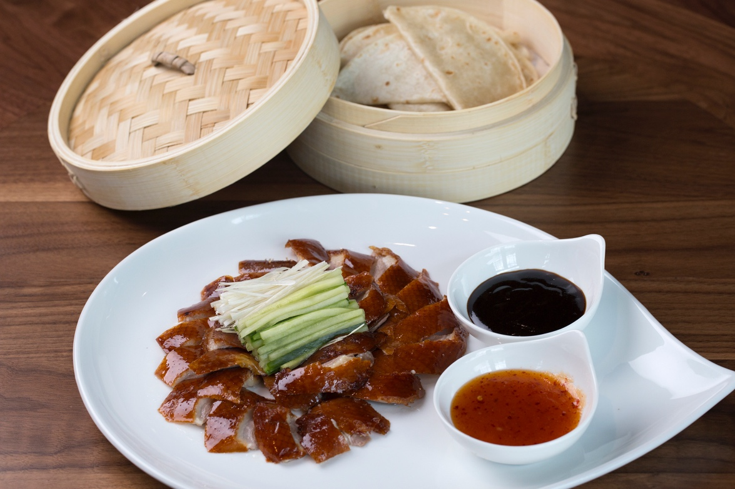

Serves 2

Ingredients:

Dry Rub
2 oz salt
1 oz sugar
1 oz star anise
1 oz bay leaf
1 oz Szechuan peppercorn
1 oz five spice

Peking Duck Brine
2 cups water
½ cup honey
½ cup vinegar
1 oz cooking wine

Apricot Glaze
2 cups apricot jam
cup sweet chili sau
1 cup rice vinegar

Rub the duck under the skin with dry rub, mix all the ingredients for the brine heat up to incorporate.
Allow brine to cool down but still warm and brine the duck for a couple of minutes. Take out of brine and allow to sit to air dry.

Put the oven to 356f and cook for 1 hour.

Serve with Apricot glaze, julienne cucumbers, scallions and Hoisin Sauce.

About Morimoto Asia
Located in the heart of Disney Springs in a neighborhood called The Landing, Morimoto Asia is the first-ever collaboration between Iron Chef Masaharu Morimoto and Patina Restaurant Group, a bicoastal leader in the premium segment of the hospitality industry. Fronted by a dramatic, three-story glass entryway, Morimoto Asia is an eye-filling showplace of dining spaces, open terraces, an intimate 14-seat sushi bar, Forbidden Lounge cocktail and late-night dining hotspot and an exhibition kitchen that allows diners a glimpse of the culinary action. Follow along on Facebook, Twitter and Instagram @MorimotoAsia. Phone: (407) 939-MOTO.

